Geographic patterns: Geographical Pattern means the "pattern" of whatever geographical events you're focusing on. For an example, When we're talking about the location of where the volcanic eruptions occur on a map, you'll be able to find a "pattern", which is;
- The volcanic eruptions are most likely to occur around the edge of the pacific, Which is also equivalent to the "ring of fire".
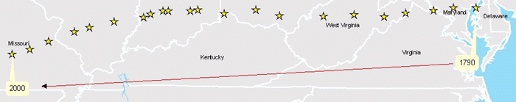

Hierarchy: Hierarchy involves the observation that patterns at one scale are often connected to patterns at a different scale. For instance, a map of U.S. cities portrayed as circles of a size proportionate to their population will show many small circles and only a few large ones. Initially, the map may be seen as a static picture, but applying the concept of hierarchy, relationships may be implied between the small and large cities. Generally, small cities depend on specialized services that can only be supported in large cities. One example would be the dissemination of news.

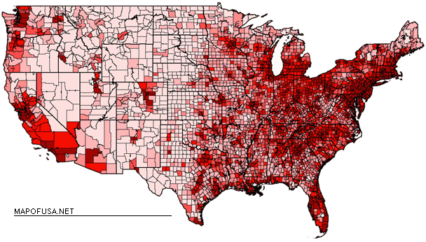

Accessibility: Related to the concept of hierarchy is accessibility, a measurement of how easily one place can be reached from all others. Large cities become large because they occupy locations that make reaching a widespread population much easier than from small cities that occupy less accessible points. For instance, in southern Delaware, given where people are located and the network of roads people use to travel between places, Dover is the most accessible point. Seaford, Lewes, and Milford are examples of towns with medium accessibility while Harrington, Bridgeville, and Felton have relatively low accessibility.

Diffusion: Movement of ideas from one location to another.

Complementarity: A final principle, complimentarity, addresses the likelihood that two places will interact in some way.

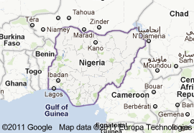

Site: Exact location

Site Factors
• reliable water supply
• away from flood risks
• defense
• building materials (stone or wood)
• fertile land
• shelterered from winds
• fuel supply (wood)
• south-facing slope (aspect)
• flat land, easy to build on
• natural harbor

Situation: Situation is defined as the location of a place relative to its surroundings and other places. Factors included in an area's situation include the accessibility of the location, the extent of a place's connections with another, and how close an area may be to raw materials if they are not located specifically on the site.

Situation Factors
• route centre
• gap town
• lowest bridging point on a river
• port
• minerals for export

Site vs. Situation: Are all sites great situations?

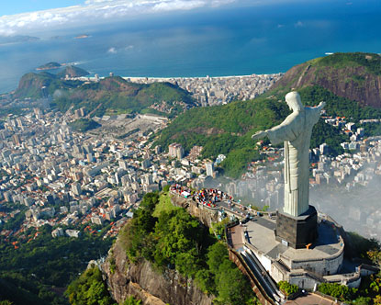

5 themes of geography?

Regions

Movement

Location

Place

Human and environmental interactions

Types of maps:

Climate Maps - give general information about the climate and precipitation (rain and snow) of a region. Cartographers, or mapmakers, use colors to show different climate or precipitation zones.
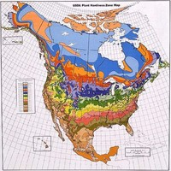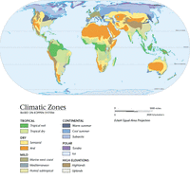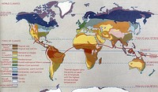

Economic or Resource Maps - feature the major types of natural resources or economic activity in an area. Cartographers use symbols to show the locations of natural resources or economic activities. For example, wheat on a map of Maryland tells you that wheat is grown there.
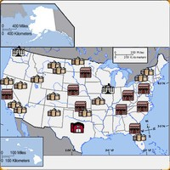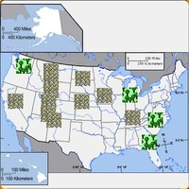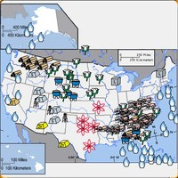

Physical Maps - illustrate the physical features of an area, such as the mountains, rivers and lakes. The water is usually shown in blue. Colors are used to show relief—differences in land elevations. Green is usually used at lower elevations, and orange or brown show higher elevations.
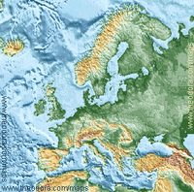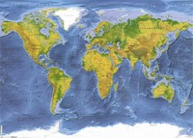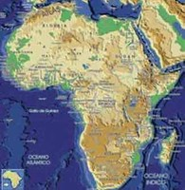

Political Maps - do not show physical features. Instead, they show state and national boundaries and capital and major cities. A capital city is usually marked with a star within a circle.
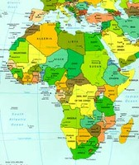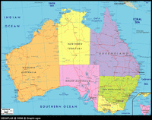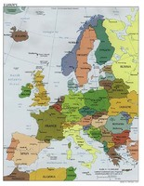

Street Maps/Road Maps - street maps illustrate smaller areas such as towns and cities. People use street maps to find directions to a place they want to go. A road map shows the highways or interstates. These maps are also used to find directions.
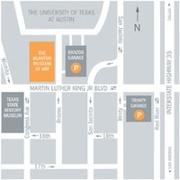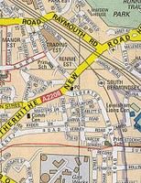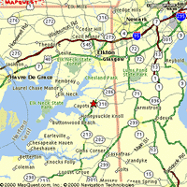

Topographic Maps - include contour lines to show the shape and elevation of an area. Lines that are close together show steep terrain, and lines that are far apart show flat terrain. Many hikers use topographic maps, especially in areas where there are no roads with signs. Geologists depend on topographic maps to record the types of rocks. Engineers use topographic maps when they are planning roads, buildings, or other human–made structures.
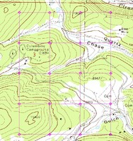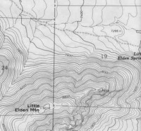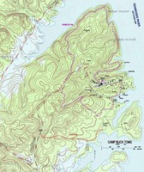

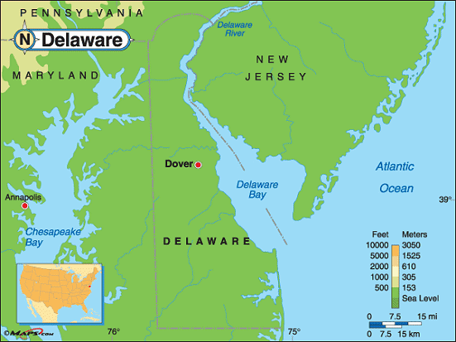

Analyze the site and situation for Delaware. Positives? Negatives?

Where are the Hospitals of Delaware? Where might the next hospital go? Why does Dover have an expanding hospital? Why not build another hospital?
